QUESTION ONE   
A system call is a controlled entry point into the kemnel, allowing a process to request that the kernel perform some action on the process's behalf.

To demonstrate a system call, Write a C program that opens a file, writes "Hello World" to it, reads the cotlent back, and then prints the read content. Finally, close the file.

Ersure you document (comment) every line of code in your program.

#indude <stdia.h> // Indlude the stardard input/butput library

#indude <sldlib.h> // Indlude the standard library

int main() {// Start of the main function

FILE 'file; // Declare a FILE pointer

// Open a file in write mode

file = fopen("example.bd", "w"];

if (file == NULL) {W If the file carnot be apened

printi("Error apening file!in"); I/ Print an error message

exit(1); // Exit the program

1

// Write "Helo World" to the file

fprintfi(file, "Hella Warldin"):

N Close the file

fdlosc(file);

// Reapen the file in read mode

file = fupen("example.bd", "r")

if (file == NULL) {// If the file carnot be opened

printi("Error apening file!in"); /f Print an error message

exit(1); // Exit the program

char line[100]; W/ Dedare a character array to store the line

// Read the line from the file

fgets(line, sizcof(line), file);

// Print the read conterit

printf("Read content: %s", line);

W Close the file

fdlosc(file);

retumn 0; // End of the main function  
  
  
QUESTION 2   
  
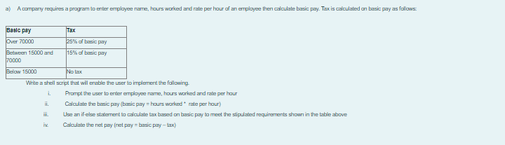  
  
#!/bin/beush

#Prompr me user ro enter employee name, hours worked and rave per hour

echo "Enter Employee Name:"

read name

echo "Enter Hours Workedt"

echo hours_worked

echo "Enter Rate per Hour."

echo rate_per_hour

#Calculare mhe basic pay

basic_pay=$(echo "Shours_worked * Srate_per_hour" | bc)

Use an If-else sravemenr to calculave tax based on basic pay

(( $(echo "Sbasic_pay > 70000"| be-l) )]; ther

tax=$(echo "Sbasic_pay * 0.25" | be)

if (( $(echo "Sbasic_pay >= 15000 && Stsic_pay <= 70000" | bc-I) )k; then

tax=$(echo "Sbasic_pay * 0.15" | be)

#Calculare zhe ner pay

net_pay=$(echo"$basic_pay - Stax" | bc)

#Print the resutrs

echo "Emplayee Name: Sname"

cho "Basic Pay: Sbasic_pay"

echo "Taxc Stax"

echo "Net Pay: Snet_pay"  
  
  
  
  
QUESTION 3  
a) You are tasked with creating a shell script to calculate and display the

electricity bill for a given customer based on the units consumed. The program

should consider different charging rates and apply surcharges as specified.

Implement the program using the provided criteria. The charges are as followCharges per unit (Ksh)

120

200 and above but less than 40015400 and above but less than 600180\

600 and above

Units

upto 199Calculate the total bill

Write a shell script to implement the following

Prompt the user to enter CustomerID, CustomerName and

UnitConsumed

Use an if .. else statement to check the above given conditions and

apply the necessary calculations

solution code   
#!/bin/bash

# Prompt the user to enter Customer ID, Customer Name, and Units Consumed

echo "Enter Customer ID:"

read CustomerID

echo "Enter Customer Name:"

read CustomerName

echo "Enter Units Consumed:"

read UnitsConsumed

# Initialize the charge per unit variable

chargePerUnit=0

# Check the number of units consumed and set the charge per unit accordingly

if [ $UnitsConsumed -It 200 ]; then

chargePerUnit=120

elif [ $UnitsConsumed -ge 200 ] && [ SUnitsConsumed -It 400 ]; then

chargePerUnit=150

elif [ SUnitsConsumed -ge 400 ] && [ SUnitsConsumed -It 600 ]: then

chargePerUnit=180

else

chargePerUnit=200

# Calculate the total bill

totalBill=$((SUnitsConsumed * SchargePerUnit))

# Check for surcharges and apply them if necessary

# Assuming a surcharge criteria, e.g., 15% for bills above a certain amount

surchargeRate=0.15

surchargeAmount=0

# Apply surcharge if total bill exceeds a certain amount, e.g.

if [ StotalBill -gt 40000 ]; then

surchargeAmount=$(echo "StotalBill . SsurchargeRate" | bc)

totalBill=S(echo "StotalBill + $surchargeAmount" | bc)

fi

# Display the results

echo "Customer ID: $CustomerID"

echo "Customer Name: $CustomerName"

echo "Units Consumed: SUnitsConsumed"

enhn "Total Rill- Keh St